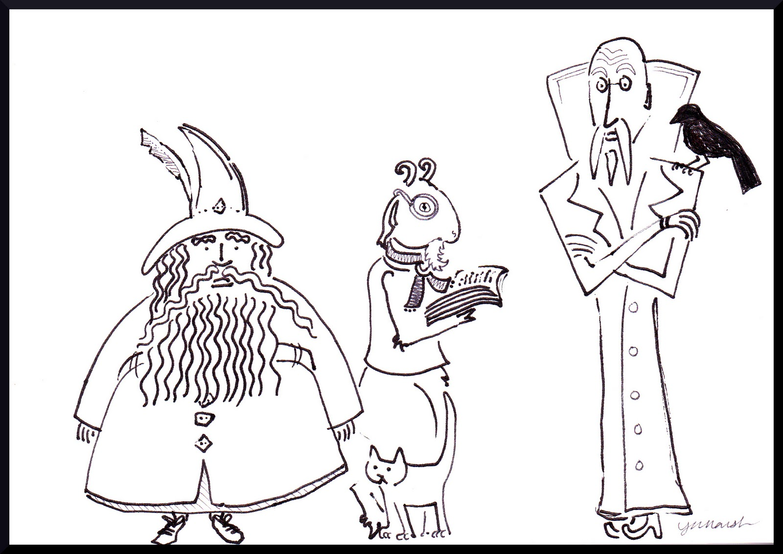
Three Wizards: Doscount School of Theurgy and Divination
Where Failure is ALWAYS An Option!

Congratulations Prospective Student!
You have been selected to attend The Three Wizards School of Theurgy and Divination. Our intensive and financially achievable school is the envy of the nine realms and you will be a part of it! In order to complete your application you will need the approval of our three Head Deans: The Wizard of Wisdom, The Wizard of Power and The Wizard of Courage. Each of these will start their challenges to you in person in the next few days. After you have completed each of their tasks, they will award you their Special Gem and with the three collected gems, you will be able to attend our school on a full scholarship! Yes, I said full scholarship. What? We'll just ding her with really expensive textbooks and lab fees like everybody else. Well, how else are we supposed to pay the creditors? Wait, are you still writing this all down? Well, don't. Erase it! What do you means magic quills don't have erase features? Well, just cross this bit out for now and make sure you leave it out when you rewrite it all.
By the way, we are fast-tracking your application because it has come to our attention that you may be about to receive a magical and Mysterious Package(tm). You are not yet prepared for its strength! Please pay this package no mind until you receive our specialized training as preparation.
We are looking forward to your certain imminent enrolment or certain magical failure, whichever comes first.
Sincerely,

Three Wizards Applications Department

This is your study book. It will give you insights into the wizarding challenges ahead of you.

This is a your new magic wand. Holding this wand means you are <<in-game>> and your answers will have consequences. Always have this on-hand when interacting with our wizarding staff.

This is your Heart Container and contains all your Heart Points. These are very precious. Do not eat your Heart Points unless instructed to do so by a wizard. Always give a wizard all the Heart Points that they demand or face total failure and death. When you run out of Heart Points, your challenges are over and you have FAILED! Do not use substitute Heart Points either as they invalidate the manufacturer's warranty and may cause inter-dimensional instability. That last part really annoys Rah and Odin the most so please, just don't...

